DoE Domain Join Tool

This tool has been developed to help laptops join the domain. When you run the script you will be prompted for an administrator eNumber and password

Automatic Behavior

When installing Windows on a laptop and you’ve not got the Ethernet cable plugged in, the tool will show an X next to the domain controller, indicating that it cannot be reached. Plug in the blue cable and hit Retry, then enter your username and password and hit Connect.

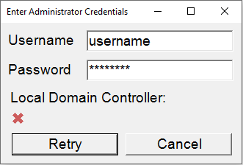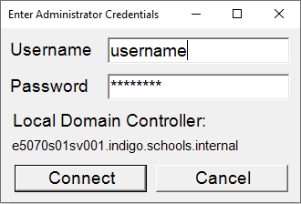

Manual Behavior

If your local domain controller isn’t appearing or it is the wrong address, you can manually specify the domain by entering your domain\username in the username box.

Before importing the script into MDT, ensure you change the site codes to the sites you work at so the script will give you the correct options. To do this, modify the top function in GetLoginCredentials.psm1.

**Modify the script**

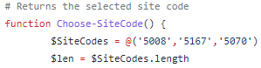

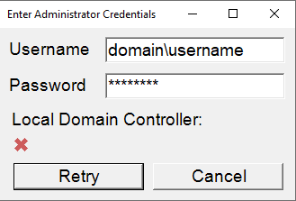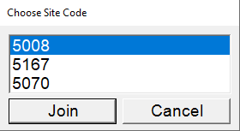**Enter your domain\username Select your site code**

Troubleshooting

The join tool will write out what it thinks the IP address and server hostname are to the PowerShell console it is run from. Note that the Server FQDN should be the fully qualified domain name, as the script strips your local domain settings from the full name.



**Please give feedback!**

If you encounter strange behavior, please email me as I would like to test more environments to ensure it remains robust. And thank you for trying it out!

timothy.blackburn@education.wa.edu.au